Compound probability distribution

PDF

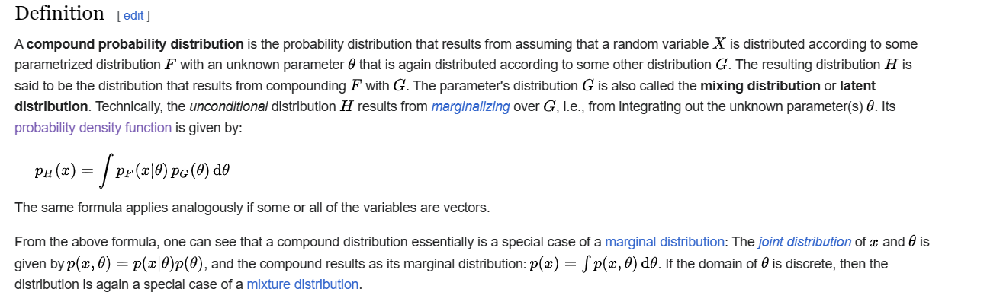

Property

Ref

[Compound probability distribution - Wikipedia](https://en.wikipedia.org/wiki/Compound_probability_distribution)